Car Parking Space Detection

Lakshmi Sahithi Pitti
Department of Computer Science and Engineering
Bapatla Engineering College
(Autonomous)
(Affiliated to Acharya Nagarjuna University)
Bapatla, India
pittilakshmisahithireddy@gmail.com

Vyshnavi Pulipati
Department of Computer Science and Engineering
Bapatla Engineering College
(Autonomous)
(Affiliated to Acharya Nagarjuna University)
Bapatla, India
vyshnavipulipati168@gmail.com

Hanumantha Rao Pasala
Department of Computer Science and Engineering
Bapatla Engineering College
(Autonomous)
(Affiliated to Acharya Nagarjuna University)
Bapatla, India
pasalahmr999@gmail.com

Sk.Asifa
Department of Computer Science and Engineering
Bapatla Engineering College
(Autonomous)
(Affiliated to Acharya Nagarjuna University)
Bapatla, India
info.skasifa@gmail.com

Abstract— Car Parking Space Detection objective is to develop a system that can accurately identify the availability of parking spaces in real-time. It utilize an SVM classifier trained on parking spot images to differentiate between empty and occupied spaces.In operation,the system analyzes video streams for spot detection.The classifier predicts spot occupancy status based on visual features, providing immediate feedback on available spaces. Experimental results confirm the system's accuracy and suitability for urban parking management.
Keywords— Real-Time parking space detection,computer vision,machine learning,SVM,occupancy prediction,urban parking management,video stream analysis,parking spot classification.

Introduction
Urbanization has led to an exponential increase in vehicular traffic, exacerbating the challenges associated with parking management in metropolitan areas. Finding an available parking spot in crowded urban environments has become a time-consuming and frustrating endeavor for drivers, resulting in traffic congestion, increased fuel consumption, and heightened pollution levels. To address this issue, there is a growing demand for intelligent parking solutions that can efficiently monitor parking space availability and provide real-time guidance to drivers.
In response to this demand, this project presents a Real-Time Parking Space Detection System leveraging advanced computer vision and machine learning techniques. The system aims to accurately detect parking spot occupancy status in real-time, enabling drivers to make informed decisions regarding parking availability. By analyzing video streams from surveillance cameras installed in parking lots or urban streets, the proposed system automatically identifies and classifies parking spots as either empty or occupied.
Key components of the system include computer vision for spot detection and a machine learning classifier trained on a dataset of parking spot images to predict occupancy status. The system operates seamlessly in real-time, providing immediate feedback to users through intuitive interfaces.

Related Work
In this section we provide relevant background on previous work on car parking space detection. Recently, several methods have been proposed for identifying spots. Many of these methods IOT-based which utilize physical sensors to detect vehicle presence and transmit data for real-time parking availability updates.
In a paper proposed [1] by by Patil et al. (2020) introduces an IoT-based system using sensors and NodeMCU. It focuses on ultrasonic sensors for detecting parking space occupancy, aiming to enhance parking management in urban areas.
In another paper [2] proposed by Rashid et al. (2018) discusses a smart parking system with IoT technologies. It utilizes sensors and microcontrollers for real-time monitoring, aiming to reduce search time and improve parking efficiency.
In other paper [3] proposed by Shaikh and Deshpande (2019) presents an automated parking system leveraging IoT. It employs sensors and microcontrollers to optimize parking space utilization and enhance user convenience.

In our work, we've implemented a smart parking system leveraging machine learning and computer vision techniques. By utilizing these technologies, our system accurately identifies parking space occupancy in real time without the need for ultrasonic sensors. Its integration of advanced algorithms enhances parking management efficiency and user experience, offering a viable solution to urban parking challenges. We conducted thorough analysis, achieving a high accuracy score in our evaluations.

Model
Machine learning involves teaching computers to learn from data and make predictions or decisions without explicit programming.

A. Support Vector Machine (SVM)
Support Vector Machine (SVM) is a supervised learning algorithm used for classification and regression tasks. In classification, SVM aims to find the optimal hyperplane that separates the data points into different classes with the largest possible margin. Data points that are closest to the hyperplane are called support vectors.

In this model, SVM is used as the classifier to classify parking spaces as either "empty" or "not empty" based on features extracted from images of parking spots. The SVM algorithm learns to classify the parking spaces by finding the hyperplane that best separates the training data into the two classes ("empty" and "not empty").

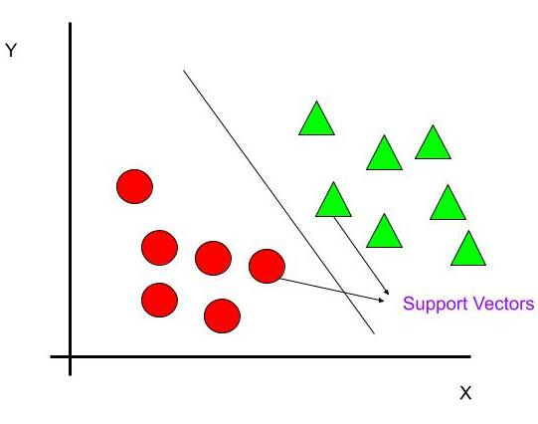
Figure III.1:Support Vector Classifier (SVC)

Support Vector Classifier (SVC) is a type of supervised learning algorithm used for classification tasks. It belongs to the family of Support Vector Machines (SVMs).
SVC works by finding the hyperplane that best separates the classes in the feature space. The hyperplane is chosen in such a way that it maximizes the margin, i.e., the distance between the hyperplane and the nearest data points from each class, called support vectors.
SVC is effective in high-dimensional spaces and is capable of capturing complex relationships in the data by using different kernel functions such as linear, polynomial, and radial basis function (RBF) kernels.In classification tasks, SVC learns from labeled training data and predicts the class labels of unseen data points based on their features.

Experiment
We conducted extensive experiments to evaluate the performance of machine learning models, considering various metrics, architectures, and datasets. Through these evaluations, we aimed to assess the effectiveness of our models in accurately detecting parking space occupancy and compare our findings with prior research in the field.

A. Dataset
We used dataset that comprise of images from some of the frames of input video, this images portray parking spaces, each annotated with labels indicating whether the space is "empty" or "not empty," depending on vehicle presence. These images serve as the foundational data for training machine learning models to accurately discern parking space occupancy in real-time scenarios.

During preprocessing, the images undergo resizing and transformation processes to convert them into numerical formats conducive to machine learning. Key features such as pixel values and texture characteristics are extracted from the images, enabling the models to learn relevant patterns and associations. Through this dataset, the system gains the necessary insights to effectively identify and classify parking space occupancy, thereby enhancing parking management efficiency and user experience.

B. Performance Metrics

To assess the performance of model prediction, we used various metrics as described below:

a) Accuracy: It measures the proportion of correctly classified samples out of the total number of samples.
.

b) Precision: It indicates the proportion of true positive predictions out of all positive predictions, focusing on the accuracy of positive predictions.

c)Recall: Also known as sensitivity, it measures the proportion of true positive predictions out of all actual positive samples, focusing on the ability of the model to identify positive samples.

d) F1-score: It is the harmonic mean of precision and recall, providing a balanced measure of a model's performance, particularly when dealing with imbalanced datasets.

Results
The system implements a smart parking system using machine learning and computer vision. Users interact with the system through a web interface to upload images and videos of parking spaces. The system processes the uploaded data, detects parking spots, and determines their occupancy status in real-time. By providing accurate updates on parking space availability without the need for ultrasonic sensors, the system enhances user experience and facilitates efficient parking management in urban areas.

Various images have been subjected to testing, and the following result is obtained.
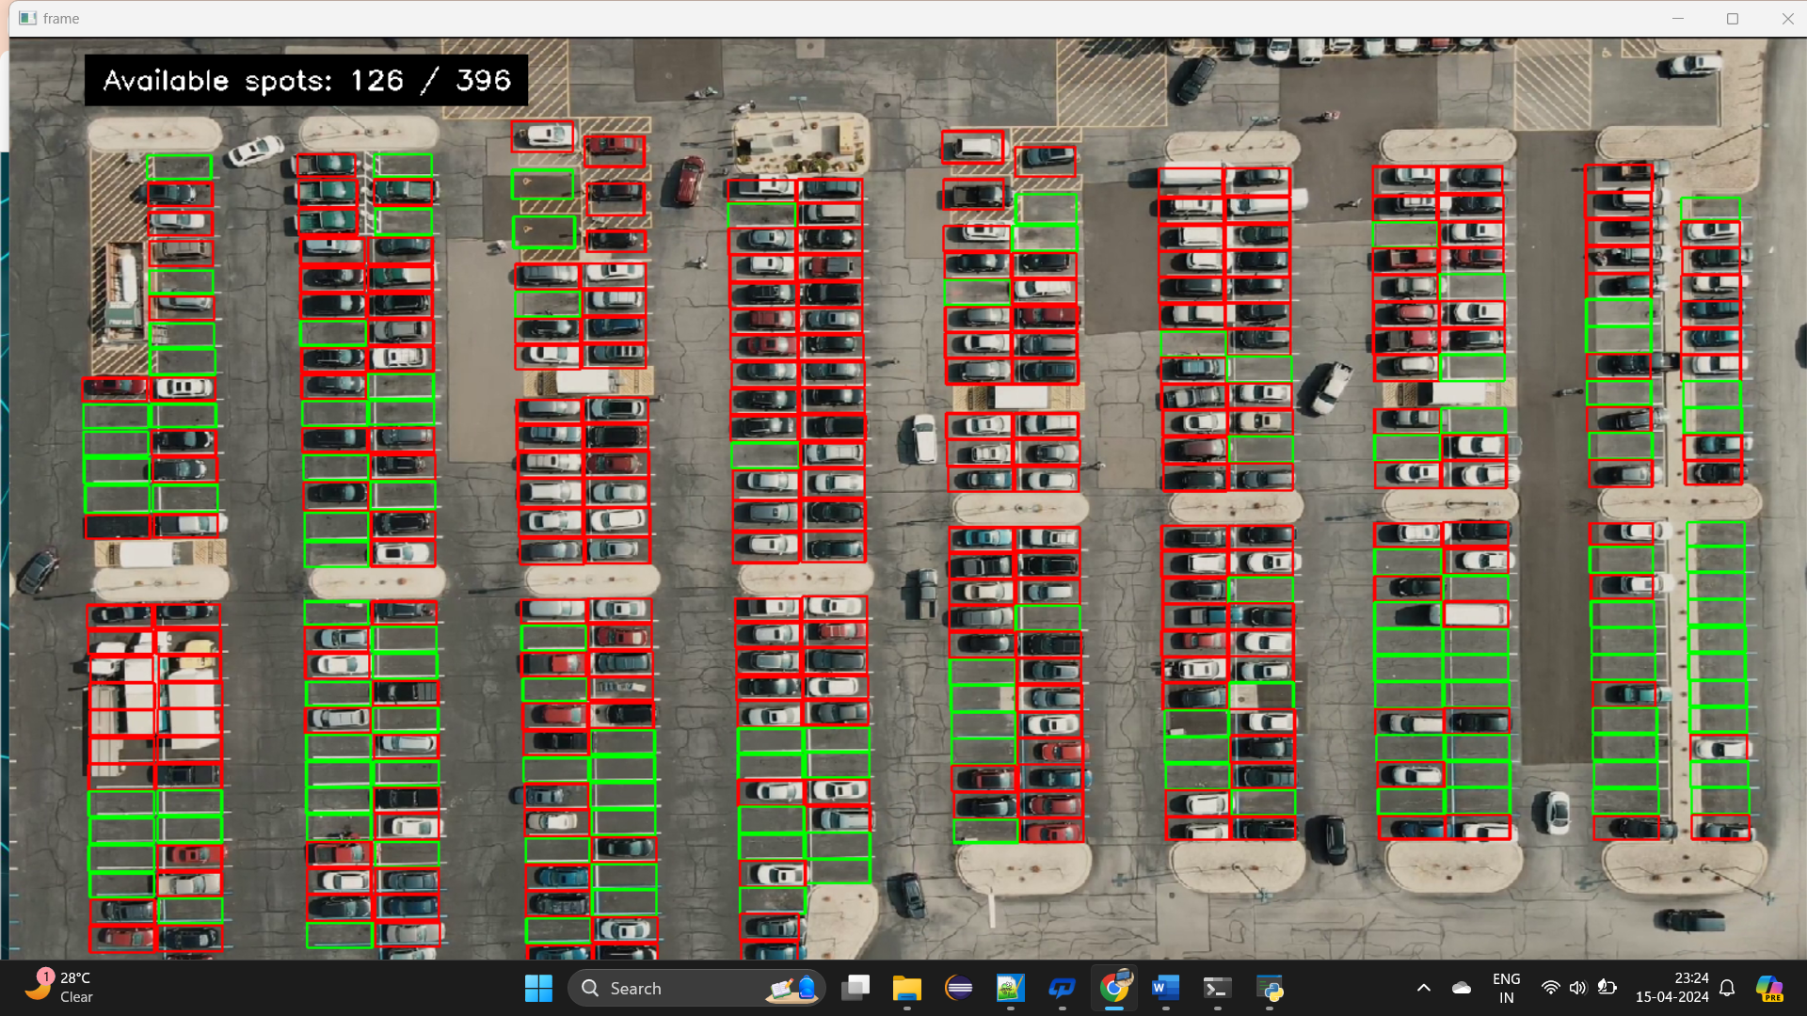
Figure V.2 Result

A. Classification Metrics

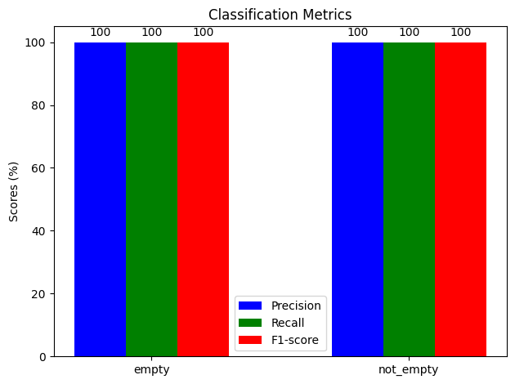
Figure V.3 Metrics using Precision, Recall and F1- scores
From the above scores comparison we can say the SVM model gave better performance compared to other methods

Conclusion
Our Experiment meticulously evaluated SVM with grid search optimization for real-time parking space detection, achieving superior accuracy in occupancy classification. This underscores the potential of machine learning in revolutionizing parking management, offering robust solutions for urban challenges.

We anticipate that the outcomes of this study will stimulate further exploration into innovative techniques for parking space detection. Such advancements could revolutionize parking management systems, leading to more efficient and sustainable urban environments.

Acknowledgment
The authors would like to thank professor Mr. T. Y. Srinivasa Rao for guiding throughout the work and the authors would also like to thank Show, Attend and Tell research paper writers for providing base to our work

References

[1] Patil, P. S., Almel, N. D., Padaganur, S. K., Ayyangoudar, B., Gokak, M. R., & Mirajkar, K. (2020). "IOT Based Car Parking." IEEE DOI:10.1109/B-HTC50970.2020.9298002. Conference: 2020 IEEE Bangalore Humanitarian Technology Conference (B-HTC).

[2] Rashid, A., Salahuddin, M. A., Islam, M. S., & Islam, M. S. (2018). "Design and Development of Smart Car Parking System using Internet of Things." 2018 International Conference on Computer, Communication, Chemical, Material and Electronic Engineering (IC4ME2). IEEE. DOI:10.1109/IC4ME2.2018.8427323.

[3] Shaikh, S. S., & Deshpande, M. (2019). "Automated Car Parking System using Internet of Things." 2019 International Conference on Sustainable Computing and Advanced Artificial Intelligence (ICSCAA). IEEE.

[4] Maheshwari, P., & Tyagi, S. (2019). "Smart Car Parking System using Internet of Things." 2019 International Conference on Emerging Trends in Information Technology and Engineering (ic-ETITE).

[5] Zhang, J., Ma, L., Jiang, H., Cao, S., Wang, H., & Wei, H. (2019). "A Vehicle Detection Method Based on Deep Learning in Parking Lot." 2019 IEEE International Conference on Image Processing (ICIP).

[6] Hsu, C. L., & Shih, C. S. (2019). "A Fast and Low-Cost Detection Method of Empty Parking Spaces Based on Convolutional Neural Networks." 2019 IEEE 5th International Conference on Computer and Communications (ICCC).

[7] Bhuvaneswari, K., & Krishnaraj, N. (2020). "Real-Time Car Parking Slot Detection System Using OpenCV." 2020 6th International Conference on Advanced Computing and Communication Systems (ICACCS). IEEE.

[8] Guo, C., Yao, Y., & Wang, J. (2020). "An Object Detection Method of Parking Lot Based on Single Shot MultiBox Detector." 2020 IEEE International Conference on Artificial Intelligence and Computer Applications (ICAICA). IEEE.

[9] Hu, Y., Zhu, Y., Chen, J., & Shang, Y. (2021). "Research on Car Parking Space Detection Algorithm Based on Deep Learning." 2021 International Conference on Artificial Intelligence and Big Data (ICAIBD). IEEE.

[10] Chen, J., & Wu, L. (2020). "Vehicle Detection and Classification for Intelligent Transportation System Based on Deep Learning." 2020 IEEE 4th Information Technology, Networking, Electronic and Automation Control Conference (ITNEC). IEEE.

